Nama : Marcello Arvel Sudarta

NIM : 2602054184

Kelas : LA01

The JCC website is primarly being used to showcase JCC’s newest events, their booking price list, and an east way for interested customers to contact JCC. It also serves great as an introduction of JCC to somebody who might not know who or what JCC is.

This Website has 5 Main pages that is the home page where you are able to see the newest upcoming events and get to learn about what JCC is. The second main page is the Events page where visitors can see JCC’s Upcoming Events and also previous hosted events. The third page is the price page where people who are interested to host their next conference, meeting or event in JCC can look at JCC’s offers beforehand. The fourth page, Visitors can learn more about JCC’s history and also look at it’s credentials as a conference center. The last page is the Contact Us page where people who are maybe having trouble contacting JCC can send out a message to JCC.

@ Navigation Bar



In every page there is a navigation bar that will help the user to navigate around the website.

@ Footer



Fotter acts as a sign that it is the end of the webpage. Visitors can sign up to our newsletter through it and go to our support page if they have problems on navigating or can’t find what they are looking for. On the very bottom there is also our social media links.

**I.Home Page**

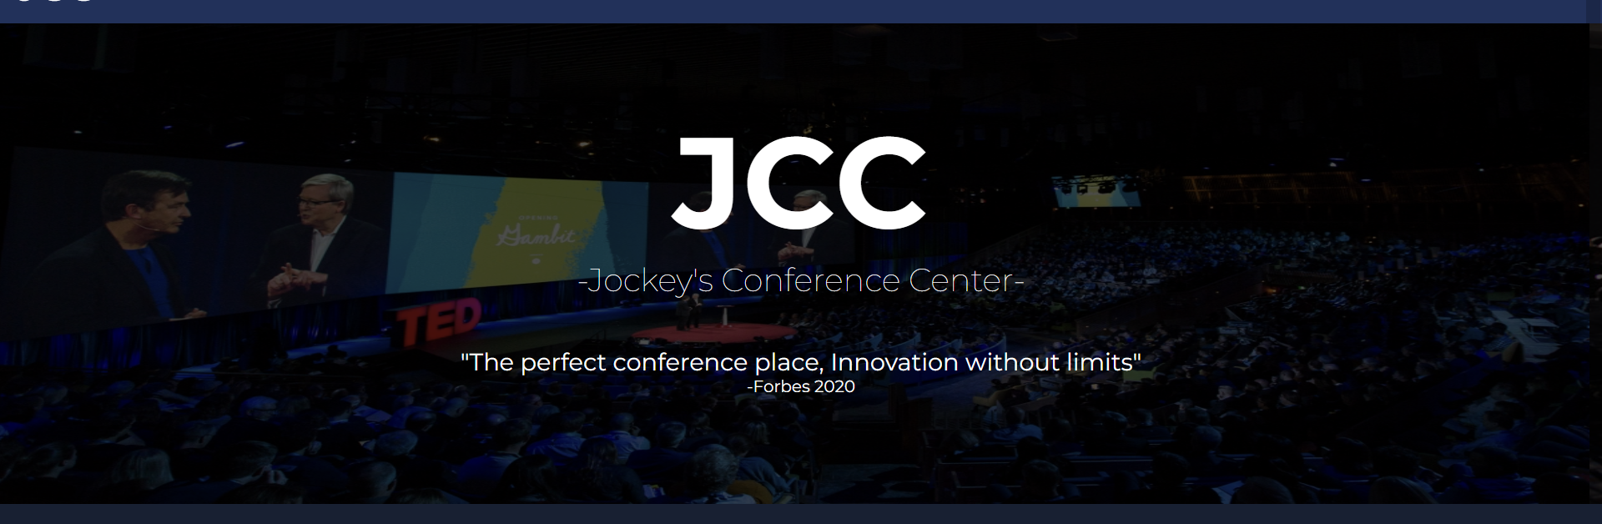

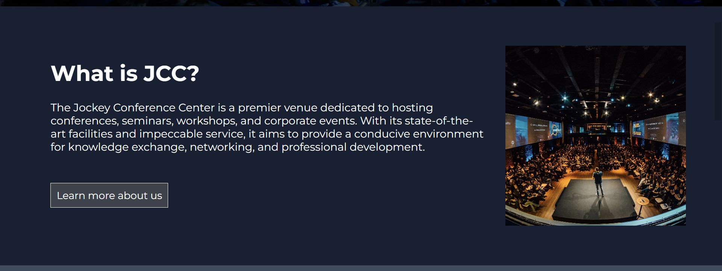

In The Home Page there is an image slider showing our previous and upcoming events. Below it theres a short paragraph about what JCC is so that visitors can understand easily what we do. The last content inside the home page there is a list of upcoming events with the event’s title. Visitors will be able to hover over it to get more info about the upcoming event.

**II.Event List**

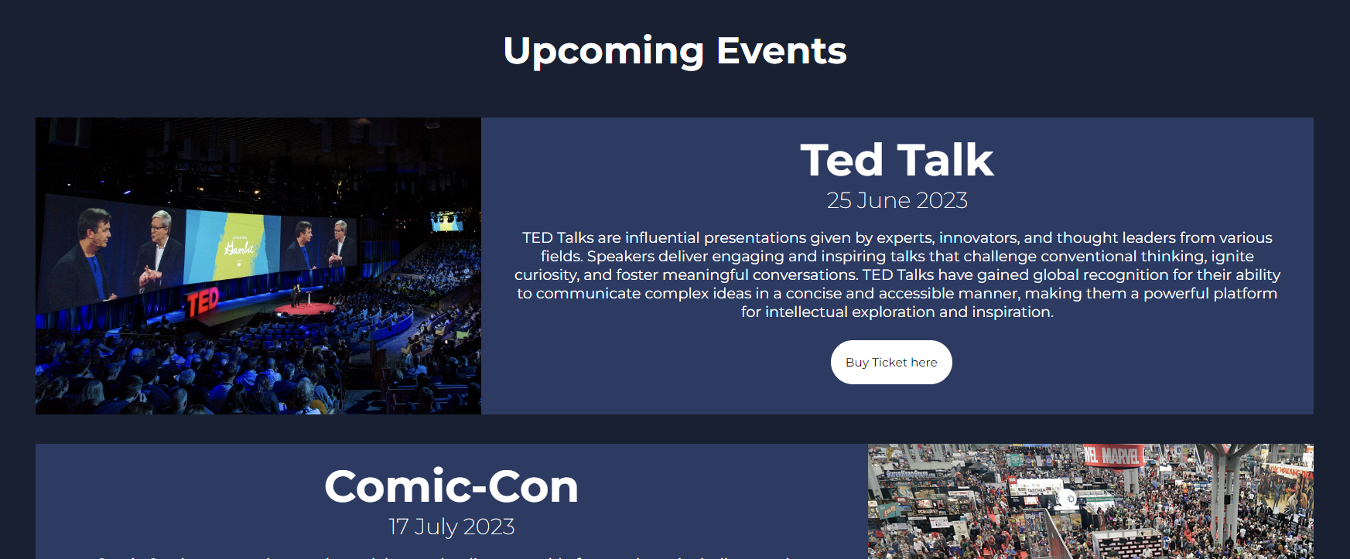

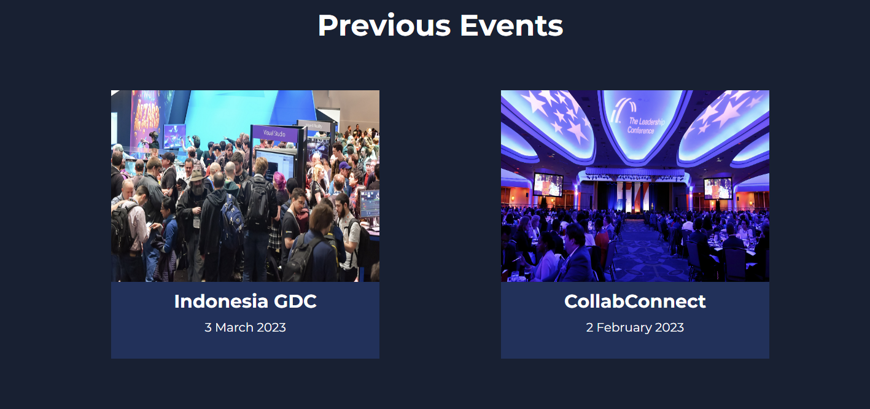

In The Event List there is an upcoming events section and a previous event section below it showing the visitors all our previous and future works.

**III. Price list**

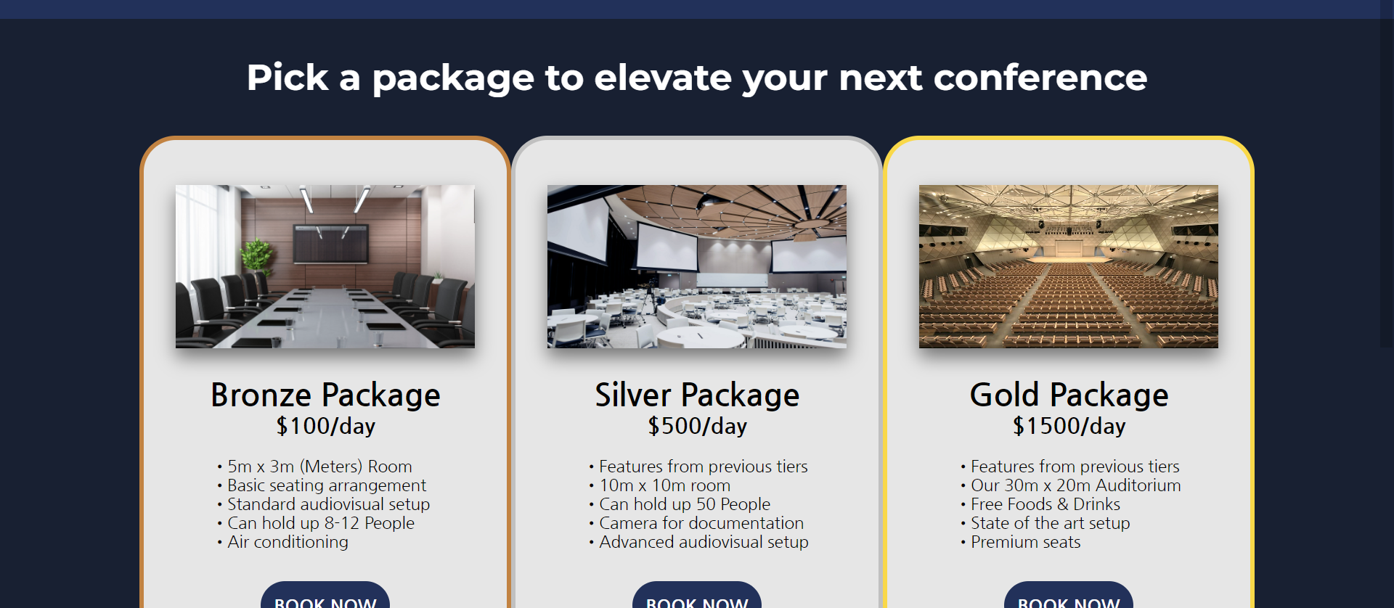

In the price list visitors can see JCC’s package deals with short information about what you can get from those packages.

**IV. About Us**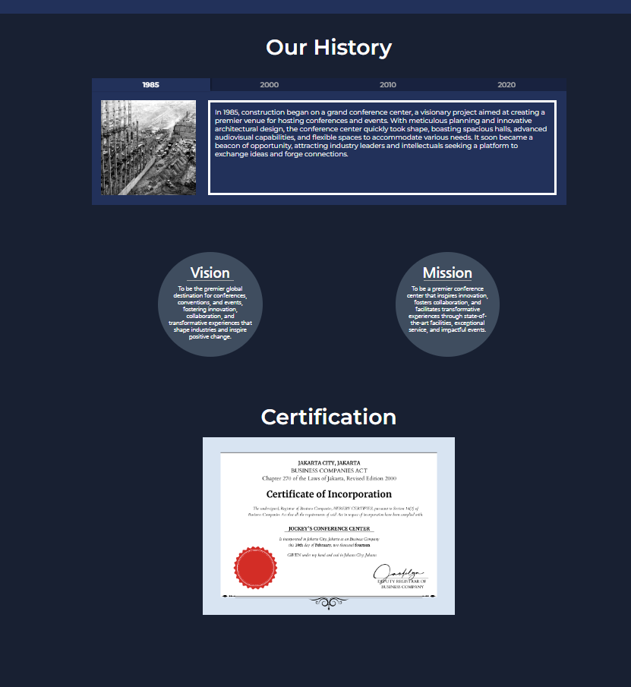

In the about us section visitors can read and see the history of our company from it’s inception until the present day. Below it there’s our company’s vision and mission. The last content of the page there is our certification as a conference center.

**V. Contact Us**

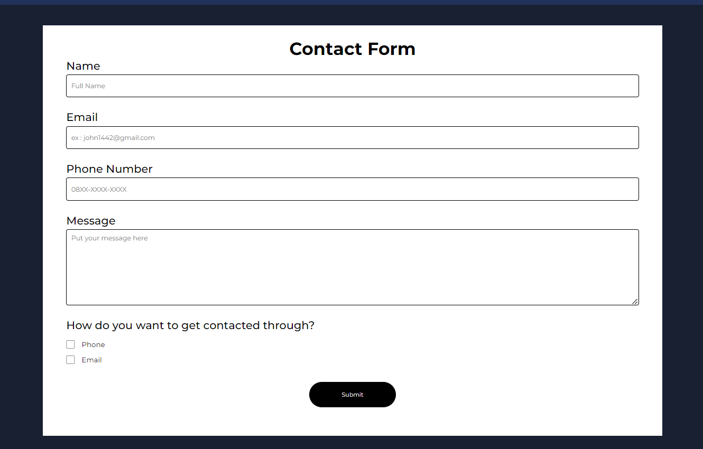

In the Contact Us page there is a form that visitors can give us messages directly. In the form there’s a validation for every text box making sure that the messages we received are not spams.

References:

Hero-1 : https://www.alphagamma.eu/opportunities/game-developer-conference-2017/

Hero-2 : https://fortune.com/2017/04/24/ted-talks-conference-corporate-sponsorship/

Hero-3 : <https://napeexpo.com/summit/events/business-conference>

Who:<https://isarta.com/infos/quelques-idees-pour-avoir-une-presence-forte-avec-ses-clients/>

Upcoming-Events-1: https://fortune.com/2017/04/24/ted-talks-conference-corporate-sponsorship/

Upcoming-Events-2:https://www.wired.com/story/san-diego-comic-con-2019-preview/  
Upcoming-Events-3: https://event.trustconference.com/event/7fd73801-77ad-4c92-a091-6df31d1e07e0

Previous-Events-1:https://www.swrve.com/resources/weblog/our-takeaways-from-the-game-developers-conference-2019

Previous-Events-2: https://www.megaron.gr/en/international-conference-centre/

Previous-Events-3: <https://www.ipm.ag/our-conferences>

Previous-Events-4: https://www.alphagamma.eu/entrepreneurship/it-tech-conferences-europe-2022/

Previous-Events-5: https://windeurope.org/annual2023/conference/

Previous-Events-6: https://www.cledara.com/blog/the-ultimate-list-of-the-125-largest-tech-conferences-in-europe-in-2020

History-Image-1:https://www.flickr.com/photos/ebrd/9681905260  
History-Image-2:

History-Image-3: https://www.montereyconferencecenter.com/

History-Image-4: <https://commons.wikimedia.org/wiki/File:ESO%E2%80%99s_new_office_and_conference_building_in_Garching.jpg>

Pack : https://www.flaticon.com/free-icons/social-media